**WEEK 1 ASSIGNMENT**

|  |  |  |
| --- | --- | --- |
| NAME: ROHIT SURYA | REG NO: 20BEC1159 | IOT – LAB 1 |

**TASK:**

In Wokwi simulator, if the distance is less than 100 cms for ultrasonic sensor, glow a LED.

**WOKWI LINK:**

https://wokwi.com/projects/365425749491990529

**Circuit Diagram:**

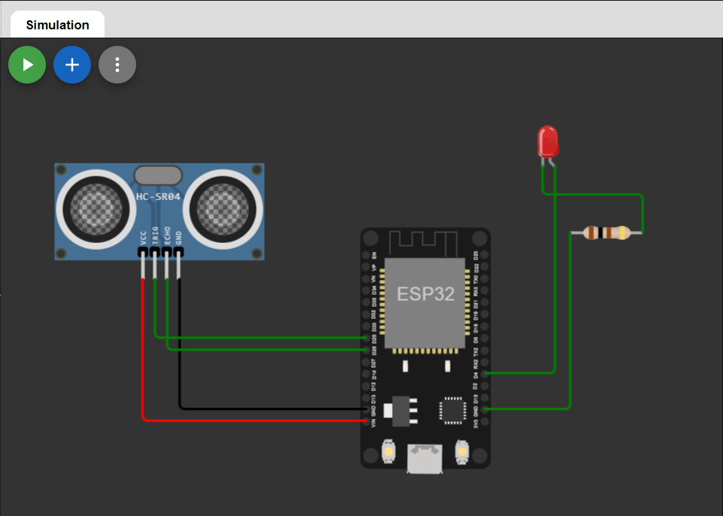

**Code:**

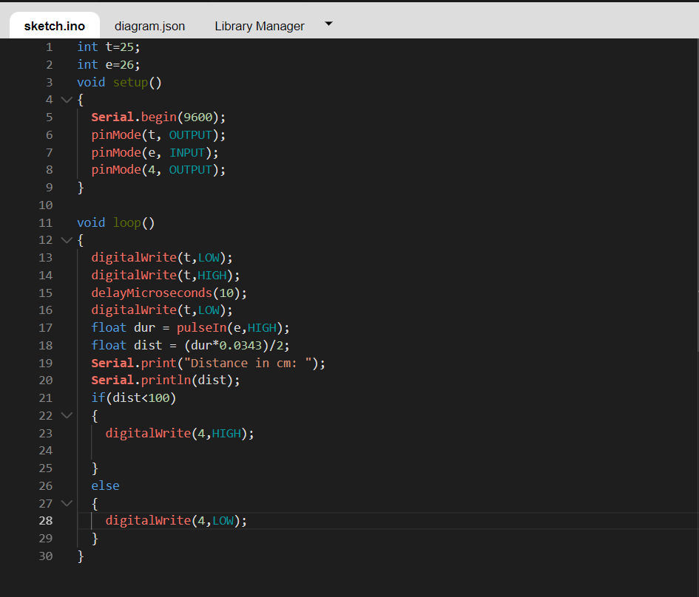

**OUTPUTS:**

When distance of ultrasonic sensor is greater than 100cm:

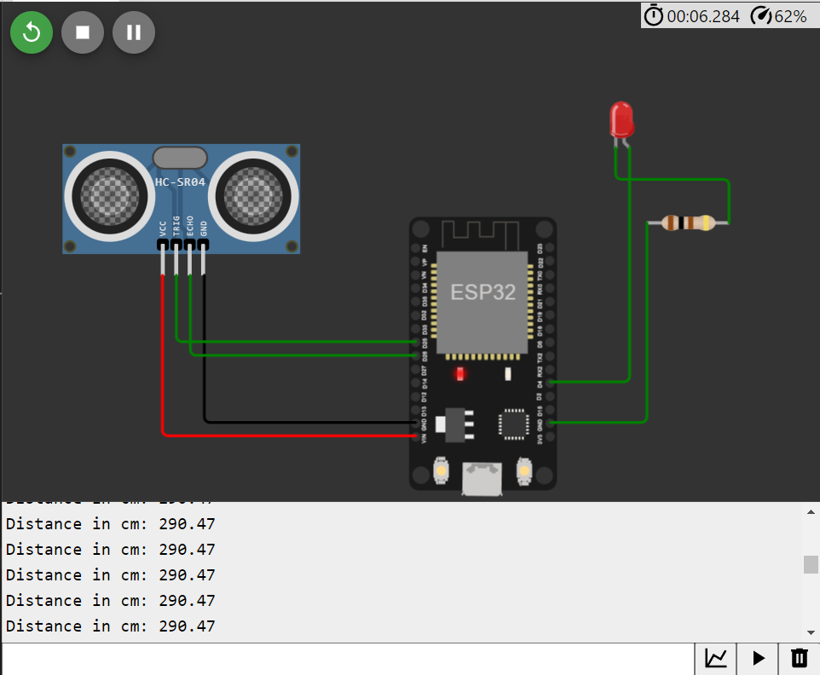

When distance of ultrasonic sensor is less than 100cm:

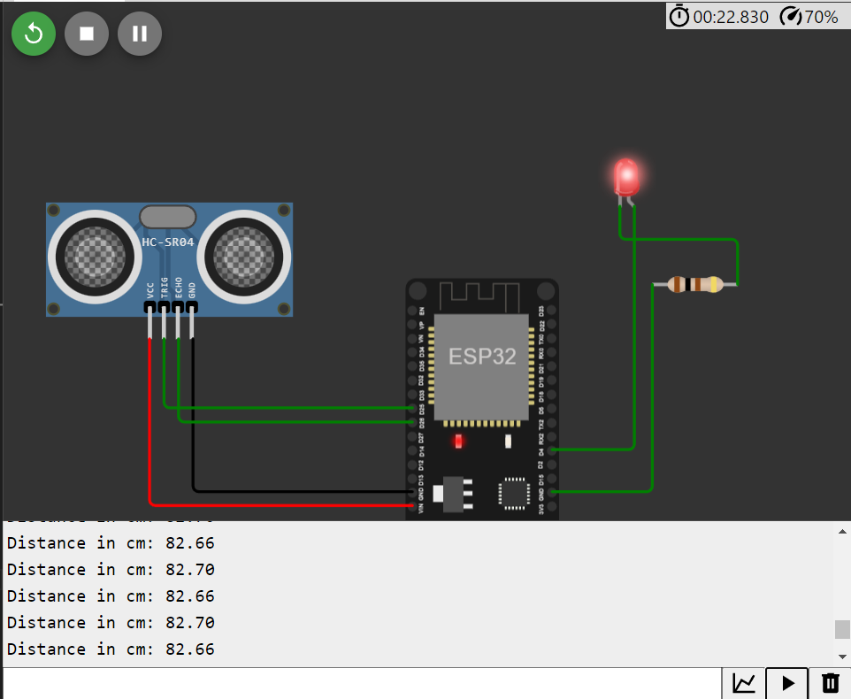

**RESULT:** Given task was carried out successfully.